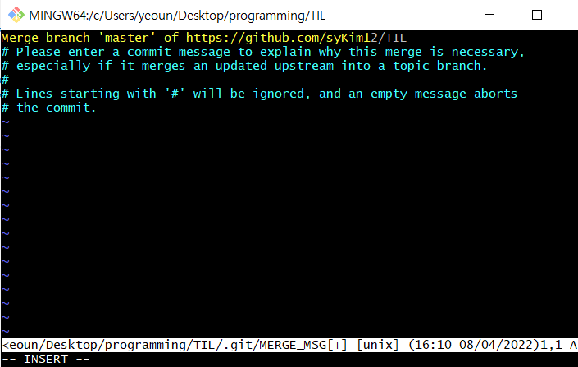

After pulling branch, entering a commit message is needed. If you meet this, you should take the steps below.

1. press "i" (i for insert)

2. write your merge message

3. press "esc" (escape)

4. write ":wq" (write & quit)

5. then press enter

If you finish step 4, then you can see a screen like below picture.

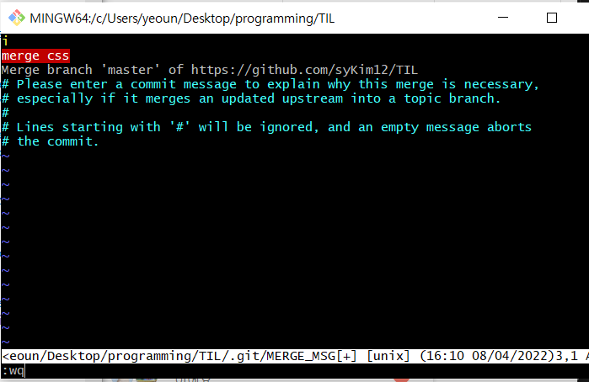

After writing ‘:wq’, you can check it’s successfully pulled like this

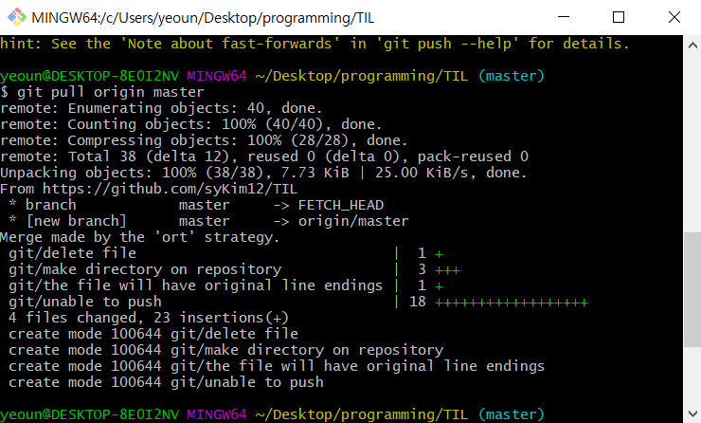

reference:https://stackoverflow.com/questions/19085807/please-enter-a-commit-message-to-explain-why-this-merge-is-necessary-especially